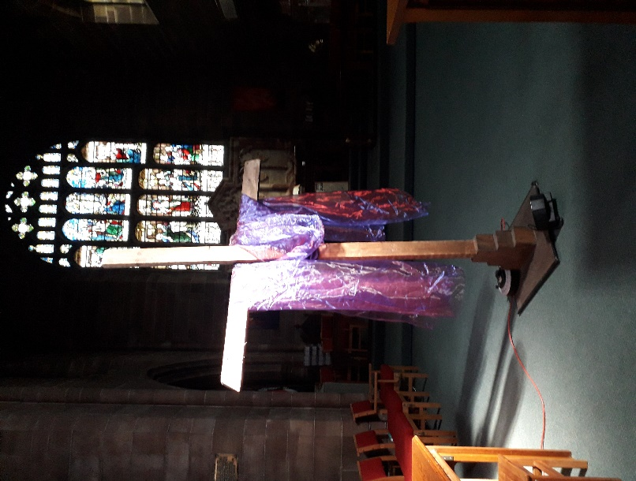
(The photo on the left is of the Lent Cross on the chancel and the photo for Mothering Sunday below is with thanks to Doreen).
A massive ‘thank you’ to all those who worked on the mission events leading up to last Sunday’s wonderful morning service. So many people came to the events over the 4 or 5 days including over 300 at the Family Fun Day on last Saturday. Pete Tomkinson’s testimony of what God has done in his life, told at the morning service was truly inspirational. Praise God for the way in which He works in people’s lives.
Service schedule for the coming weeks:
Sunday  27th March  LENT 4 |   10.30am Holy Communion with Prayer for Healing  Reading: Luke 5: 12 - 16  Leader/Celebrant: ES Preacher: VB Theme: Jesus cares  6pm Prayer Gathering/Prayer for Healing DOB/YB
Wednesday 30th March | 11am BCP Holy Communion  Reading: John 6: 1 - 14  Leader: DOB Celebrant: DOB Preacher: DOB
Sunday  3rd April  LENT 5 | 10.30am Service of the Word Reading: John 12: 1 – 8  Leader: DOB Preacher: ES  Theme: Jesus anointed at Bethany  6pm Prayer Gathering/Breaking of Bread DOB/VB
Wednesday  6th April | 11am BCP Holy Communion  Reading: John 8: 46 - 59  Leader: ES Celebrant: ES Preacher: DOB
Sunday  10th April  PALM SUNDAY | 10.30am Holy Communion  Reading: Matthew 21: 1 - 13  Leader/Celebrant: ES Preacher: DOB  Theme: Hosanna to Jesus the King  6pm Prayer Gathering/Prayer for Healing ES/CB
MAUNDY THURSDAY  14th April | Notice about service to be announced
GOOD FRIDAY  15th April | Notice about services to be announced
 | Midweek services begin again on Wednesday 27th April

PLEASE REMEMBER
THE CLOCKS GO FORWARD THIS SUNDAY 27th MARCH

Our morning and evening readings for the coming week:
 | Morning Readings | Evening Readings
Monday 28th March | Psalm 77;  Exodus 2: 11 – 22;  Hebrews 9: 1 – 14 | Psalm 25;  Jeremiah 17: 5 – 18;  John 9: 18 - end
Tuesday 29th March | Psalm 79;  Exodus 2: 23 – 3: 20;  Hebrews 9: 15 – end | Psalm 80;  Jeremiah 18: 1 – 12;  John 10: 1 - 10
Wednesday 30th March | Psalm 90;  Exodus 4: 1 – 23;  Hebrews 10: 1 – 18 | Psalm 91;  Jeremiah 18: 13 – end;  John 10: 11 - 21
Thursday 31st March  John Dunne, priest, poet, 1631 | Psalm 86;  Exodus 4: 27 – 6: 1;  Hebrews 10: 19 – 25 | Psalm 94;  Jeremiah 19: 1 – 13;  John 10: 22 - end
Friday 1st April  Frederick Denison Maurice, priest, teacher of the faith, 1872 | Psalm 102;  Exodus 6: 2- 13;  Hebrews 10 : 26 – end | Psalm 16:  Jeremiah 19: 14 – 20: 6;  John 11: 1 - 16
Saturday 2nd April | Psalm 32;  Exodus 7: 8 – end;  Hebrews 11: 1 – 16 | Psalm 140;  Jeremiah 20: 7 – end;  John 11: 17 - 27
Lord, pour out Your Holy Spirit upon us and may Your light so shine through us that together we share Your love with everyone……
(the LORD said…) Now my eyes will be open and my ears attentive to the prayers offered in this place. (2 Chron, 7: 15)

