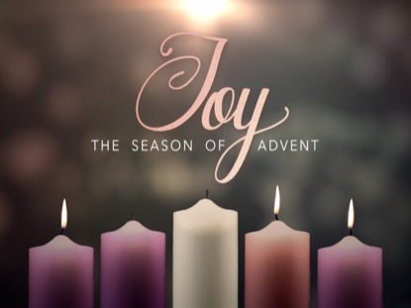**St Thomas’ Church**

*“Building the Kingdom…….”*

What a blessed Sunday at church last week – with Bishop Julian preaching and celebrating Holy Communion and our Tree Lighting service. In encouraging us to read our Bibles more, Bishop Julian gave an anecdote of someone asking an older lady ‘Do you read the Bible?’ and the answer came back ‘The Bible reads me.’ How true that is because we see ourselves in the Word of God and He speaks to us through the Bible.

This Sunday is Advent 3 when the theme is **JOY.**

***Alternative Collect for Advent 3:***

*God, for whom we watch and wait, You sent John the Baptist to prepare the way of Your Son:*

*Give us courage to speak the truth, to hunger for justice and to suffer for the cause of right, with Jesus Christ our Lord. AMEN*

*Below is the service schedule for the rest of the season of ADVENT and for our CHRISTMAS celebrations*

|  |  |
| --- | --- |
| Sunday 12th December  ADVENT 3 | 9am Holy Communion Reading: Luke 3 v 7 – 18  Leader/Celebrant: DOB Preacher: ES Theme: Clean hands and hearts  10.30am Holy Communion Reading : Luke 3 v 7 – 18  Leader: DOB Preacher: ES Celebrant: DOB  6pm Prayer Gathering VB/YB |
| Sunday 19th December  ADVENT 4 | 9am Holy Communion Reading: Luke 1 v 46 – 55  Leader/Celebrant/Preacher: DOB Theme: Mary’s Song  10.30am Service of the Word Reading: Luke 1 v 46 – 55  Leader: ES Preacher: CB  6pm **Service of Readings and Carols** |
| Friday 24th December  **CHRISTMAS EVE** | **MIDNIGHT COMMUNION**  **Starting at 11.30pm**  Reading: Luke 2 v 1 – 14 Leader: ES Preacher/Celebrant: DOB |
| Saturday 25th December  **CHRISTMAS DAY** | **10.30am FAMILY CHRISTMAS DAY COMMUNION**  Reading: John 1 v 1 – 14 Leader/Celebrant: DOB Preacher: ES |
| Sunday 26th December  Christmas 1 | **10.30am Holy Communion**  Reading: Matthew 10 v 17 – 22 Leader/Celebrant: ES Preacher: DOB |

Our morning and evening readings for the coming week:

|  |  |  |
| --- | --- | --- |
|  | **Morning Readings** | **Evening Readings** |
| Monday 13th December  *Lucy, martyr, 304* | Psalm 40; Isaiah 38 v 1 – 8, 21 – 22; Matthew 16 v 13 – end | Psalm 26; Isaiah 49 v 14 – 25;  1 Thessalonians 5 v 1 - 11 |
| Tuesday14th December  *John of the Cross, poet, teacher* | Psalm 70; Isaiah 38 v 9 – 20;  Matthew 17 v 1 - 13 | Psalm 50; Isaiah 50;  1 Thessalonians 5 v 12 - end |
| Wednesday15th December | Psalm 75; Isaiah 39;  Matthew 17 v 14 – 21 | Psalm 82; Isaiah 51 v 1 – 8;  2 Thessalonians 1 |
| Thursday16th December | Psalm 76; Zephaniah 1 v 1 – 2 v 3; Matthew 17 v 22 – end | Psalm 44; Isaiah 51 v 9 – 16;  2 Thessalonians 2 |
| Friday 17th December  *Eglantyne Jebb, social reformer founder of ‘Save the Children’* | Psalm 98; Zephaniah 3 v 1 – 13;  Matthew 18 v 1 – 20 | Psalm 49; Isaiah 51 v 17 –end;  2 Thessalonians 3 |
| Saturday 18th December | Psalm 71; Zephaniah 3 v 14 – end; Matthew 18 v 21 – end | Psalm 43; Isaiah 52 v 1 – 12;  Jude |

**(the LORD said…) Now my eyes will be open and my ears attentive to the prayers offered in this place.** (2 Chronicles 7 v 15)